1. Click “Not Registered” to begin the process of registering for online banking.

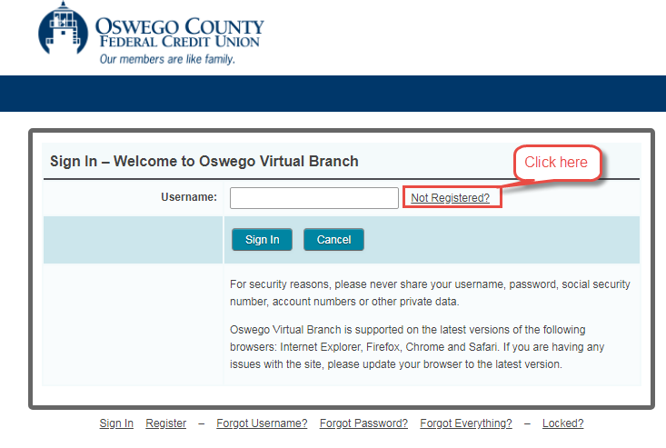

1. Complete the Account Number, Last 4 digits of SSN, Date of Birth and Accept fields and click “Start”.

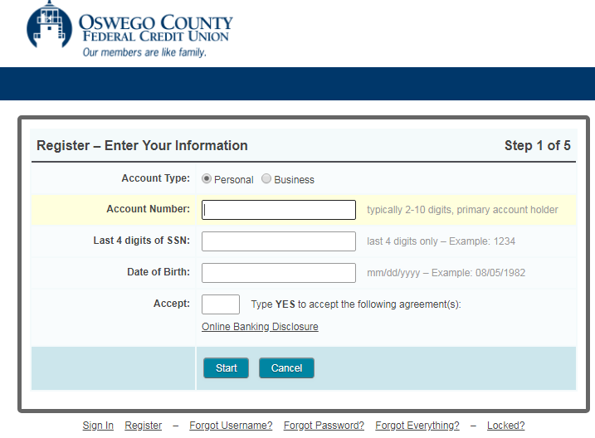

1. Click the – Send Method – drop down and select how you want to receive the one-time passcode (Text Message, Phone Call or Email) and click “Send Passcode”.

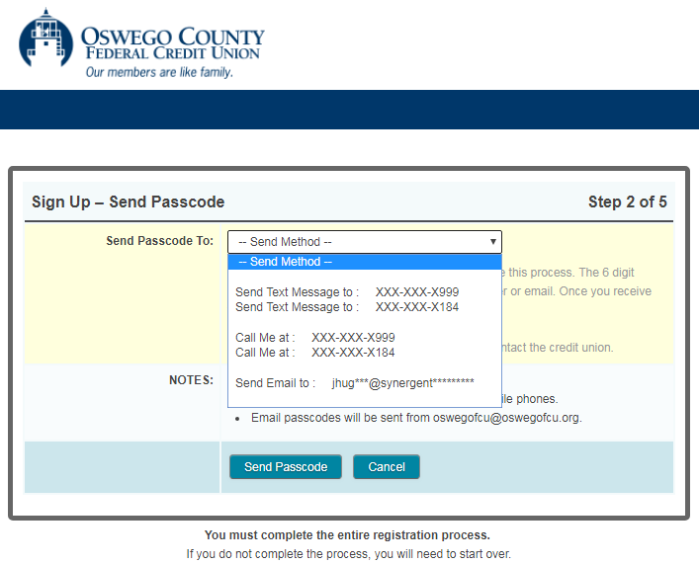

1. Enter the 6-digit passcode and click “Confirm Passcode”.

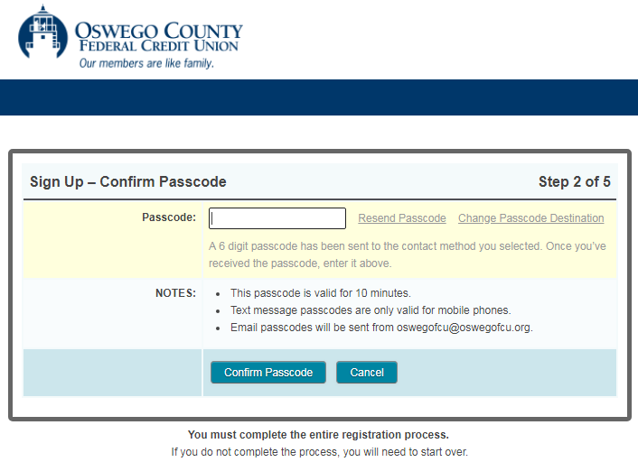

1. Complete the Set Up Username, Set Up Password, Confirm Password and Confirm Email Address fields and click “Next”.

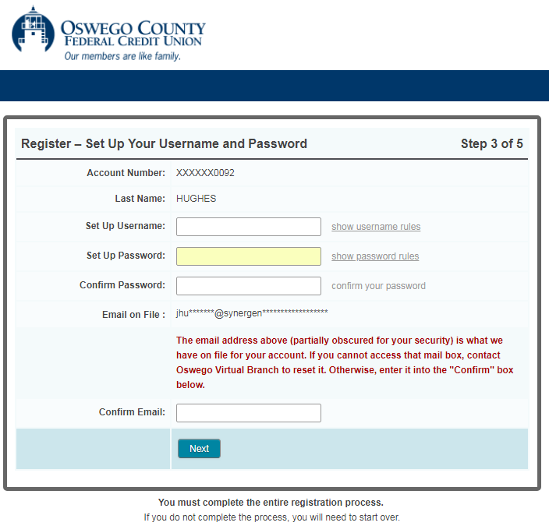

1. Complete the “Security Phrase” field and select a Security Picture.

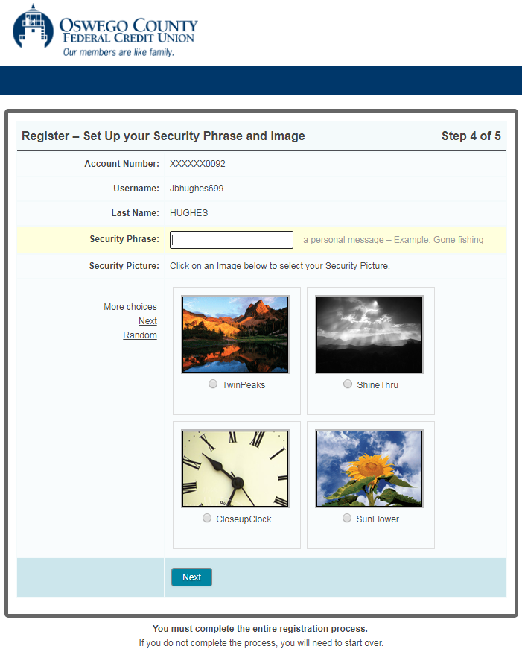

1. Wait while your online account in established and do not refresh or navigate away from this page until the process has completed.

